1.download the map of the Doubs river , and download the map as a geojson format and set the area that the river undergoes as the area of interest (AOI).

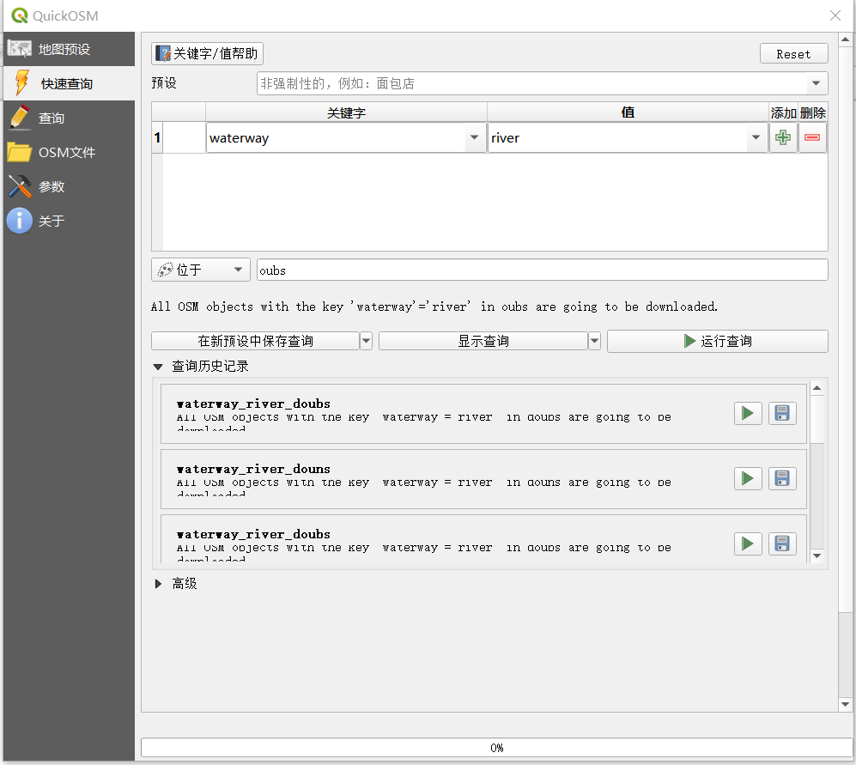

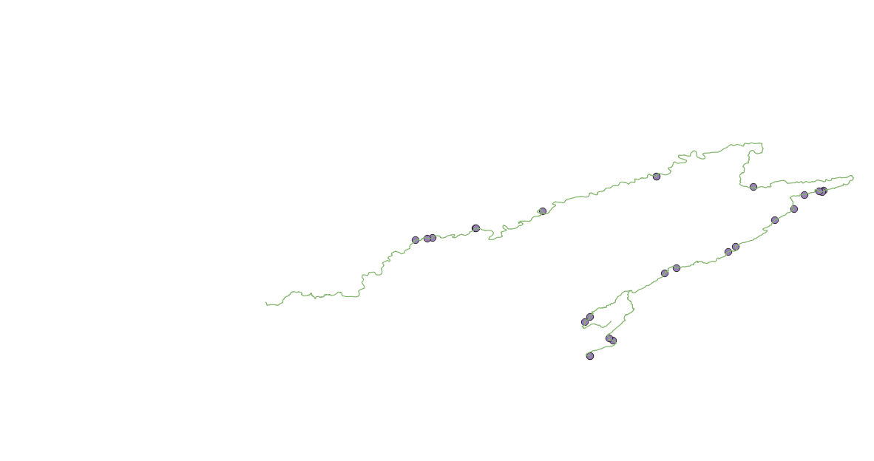

1. Create an account of one of these geospatial official websites, such as USGS, and login in for check the images that the river covers. Filtering the records to keep only Landsat images with LandCloudCover lower than 10%, and try to find what products levels.



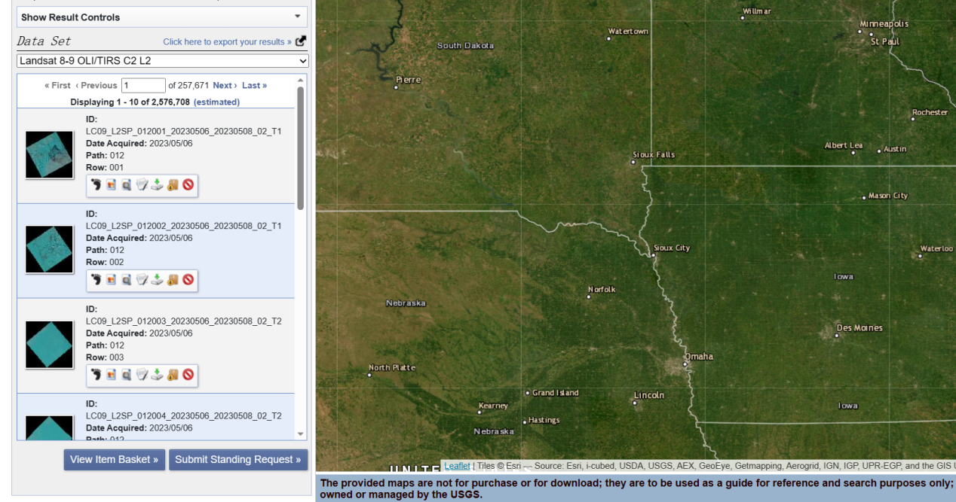

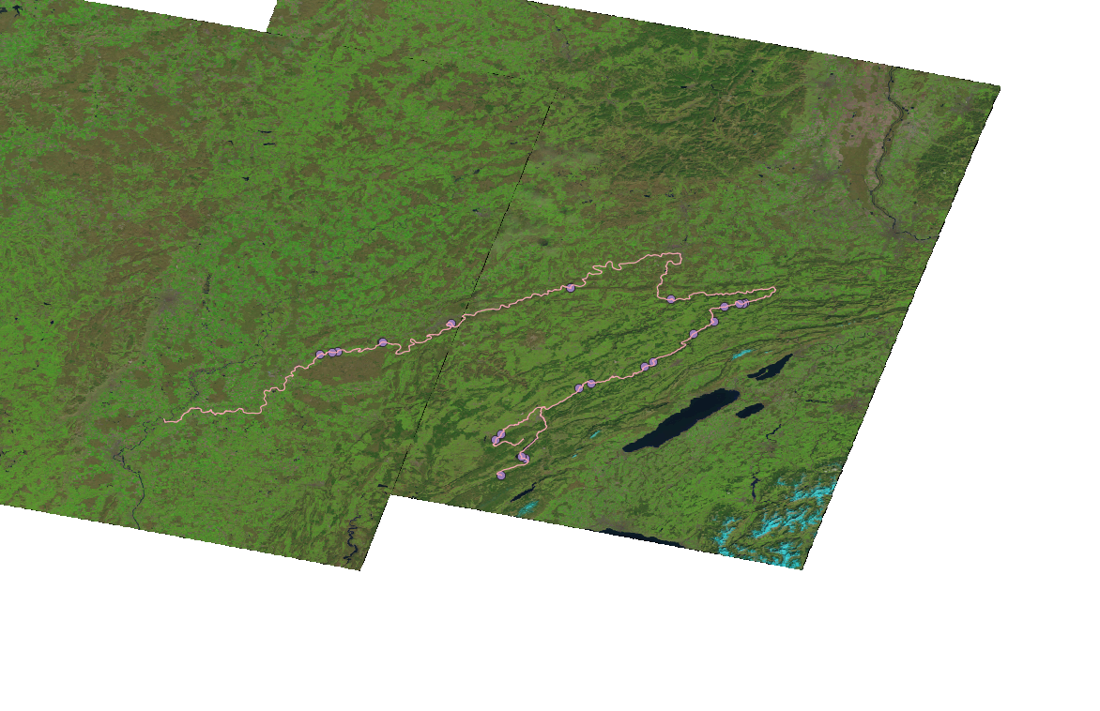3. Load the NDVI raster file and check whether its crs is identical to AOI. If not, transform the crs of AOI vector into the another which is the same as that of NDVI. After that, you can crop and mask the NDVI for a small area, which just covers the AOI.

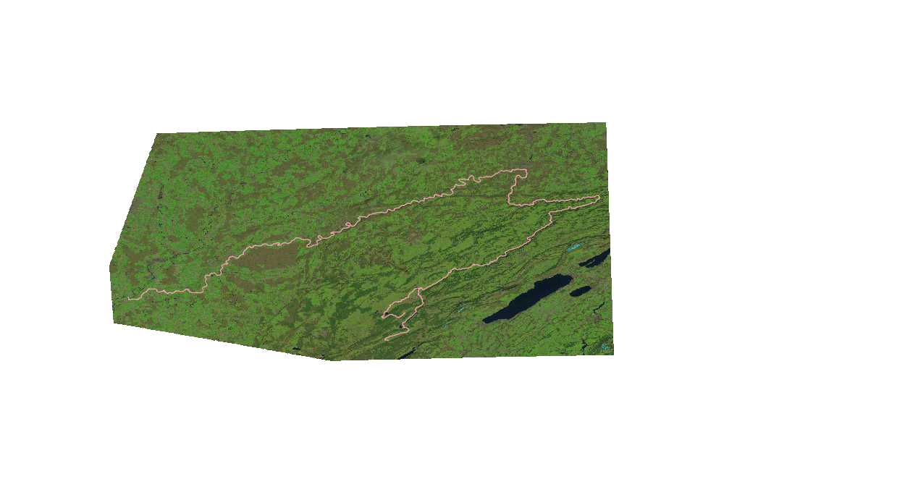

#R code

NVDI<- raster("C:/Users/86133/Desktop/NVDI/crop.tif")

plot(NVDI)

aoi<- readOGR("C:/Users/86133/Desktop/NVDI/waterway_river_doubs.geojson")

plot(aoi)

crs(NVDI)

crs(aoi)

NVDI_aoi <-crop(NVDI, aoi)

NVDI_aoi_masked <- mask(NVDI_aoi, aoi, updateNA=TRUE)

plot(NVDI_aoi)